PRELIMINARY RESEARCH PROJECT OVERVIEW FORM

CONTEXT
Bolton Clarke (BC) is a not-for-profit aged care provider, caring for older community members living in their own homes, in retirement villages and in residential aged care homes.

The BC Research Institute (BCRI) supports BC staff to provide evidence-based care to our clients and residents and generates research to support appropriate translation of evidence into BC practice. Bolton Clarke has 4 research priorities:

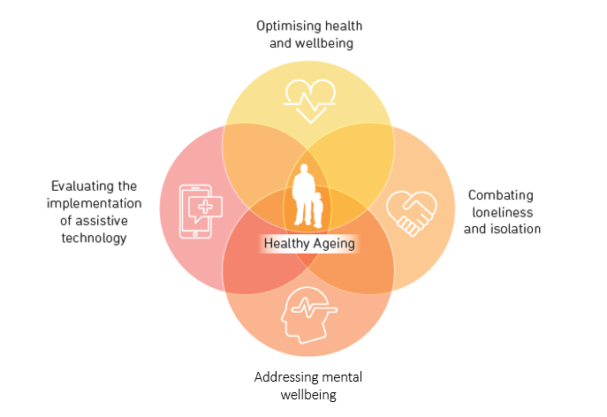

Research projects undertaken at Bolton Clarke must receive ethical approval, under consideration of the NHMRC National Statement and guidelines, from the Bolton Clarke Human Research Ethics Committee (HREC) (an NHMRC registered HREC). This committee meets bi-monthly.

All research undertaken at Bolton Clarke must include involvement and collaboration with the BCRI from the early stages of project development, and:
- Be relevant to our communities, staff, organisation and the broader aged care industry;
- Fill a gap in existing research/knowledge, with the aim of leading to positive change in care delivery;
- Have the approval of the BC HREC and the relevant Bolton Clarke stream business leader (facilitated by BCRI).

Prior to submission to the BC HREC, all project proposals must first be reviewed by the Bolton Clarke Research Review and Governance Committee (RRGC) to ensure they meet the above requirements. For this review, please complete the information requested in the following form. Please spell out all acronyms in full the first time they are used.

Date: Click or tap to enter a date.

Title of research proposal: | Click or tap here to enter text.
Name of lead researcher: | Click or tap here to enter text.
Affiliation: | Click or tap here to enter text.
Contact details: | Email: Click or tap here to enter text.  Phone: Click or tap here to enter text.
Name of BCRI researcher: | Click or tap here to enter text.
Is this a student project? (Use dropdown list) | ☐ Yes ☐ No  If yes, name of supervisors: Click or tap here to enter text.
Type of submission: (Use dropdown list) | Choose an item.  If Grant: Grant scheme: Click or tap here to enter text.  Grant submission date: Click or tap to enter a date.  Date notification of grant outcome: Click or tap to enter a date.

Project Overview

- Knowledge gap and benefit to older people (max. 250 words)
Please:
- state what gap in knowledge this work will address;
- provide evidence of a review of literature to show that this proposal is meeting a gap in evidence and isn’t duplicating previous work;
- outline how the proposed work will make a meaningful contribution to improving the health and wellbeing (physical, mental and social) of older people.

Click or tap here to enter text.

- Background / Rationale and Project Aims (max. 250 words)
Click or tap here to enter text.

- Project Participants (Tick the boxes)
☐ | At Home Support Clients | ~Number: | Click or tap here to enter text.
☐ | Retirement Living Residents (NSW, QLD) | ~Number: | Click or tap here to enter text.
☐ | Aged Care Home Residents (Circle/highlight which state: QLD, Vic, NSW, SA, WA) | ~Number: | Click or tap here to enter text.
☐ | Family members or informal carers | ~Number: | Click or tap here to enter text.
☐ | Staff members/Volunteers | ~Number: | Click or tap here to enter text.
☐ | Others |  | Click or tap here to enter text.

- Intervention/methods content and rigour (max. 500 words)
(Does the project include accepted scientific methods that are appropriate to achieve the aims? What scales or other evaluation methods will be used?; Are the tools validated (if appropriate)?)
Click or tap here to enter text.

- Describe the involvement of the Bolton Clarke Research Institute in the development of your project (max. 150 words)
(Bolton Clarke Research Institute aims to codesign all research projects, engaging older people and other stakeholders, including other researchers).
Click or tap here to enter text.

- Describe what is required from Bolton Clarke and the target participants (max. 250 words) (How much time and what is involved in participation)
Click or tap here to enter text.

- Resources
(Where possible, please include specific costs, and whether discussions have taken place with specific Bolton Clarke operational staff)
- How is this project being financed?
Click or tap here to enter text.
- Is Bolton Clarke expected to provide any funding for this project?
Yes: | ☐ | No: | ☐
If yes, please provide details:
Click or tap here to enter text.
- Is Bolton Clarke expected to provide any staff time for this project?
(n.b. for frontline staff to be diverted from care duties, staff time must be reimbursed to allow for backfill)
Yes: | ☐ | No: | ☐
If yes, please provide details:
Click or tap here to enter text.
- Is Bolton Clarke expected to provide any facilities for this project?
Yes: | ☐ | No: | ☐
If yes, please provide details:
Click or tap here to enter text.

- Describe how Bolton Clarke may benefit from this research (max. 250 words)
(Does this research align with the priorities of the organisation and the community members it supports?)
Click or tap here to enter text.

- Timeframe
Click or tap here to enter text.

- Has previous Ethics Committee approval has been obtained?
☐ Yes ☐ No

Please provide details of the ethics committee and copy of approval certificate:
Click or tap here to enter text.

Project Summary

Please provide a short project summary to populate an email to inform our Business Stream.
Please include the following information that is relevant to your project. You can re-use content from the Project Overview as long as it fits the word count.

Background/Rationale: (no more than 150 words)
Click or tap here to enter text.
Aim: (no more than 100 words)
Click or tap here to enter text.
Duration of project: (no more than 50 words)
Click or tap here to enter text.
Research Approach: (no more than 150 words)
Click or tap here to enter text.
Anticipated Outcome: (no more than 50 words)
Click or tap here to enter text.
Bolton Clarke involvement – including geographic location: (no more than 150 words)
Click or tap here to enter text.
Funding for Bolton Clarke: (no more than 50 words)
Click or tap here to enter text.
Impost on Bolton Clarke – including staff time, client recruitment, other requirements from Bolton Clarke for the study: (no more than 100 words)
Click or tap here to enter text.
Benefits for Bolton Clarke and the sector: (no more than 100 words)
Click or tap here to enter text.

This, with the above email, will provide information for the Business Stream Leader(s) to make their decision.

Thank you,
RRGC Committee.

